cosm Day 3 Post-session assignment

Risk Management & Budgeting

Purpose: To encourage course participants to review session materials and to

start implementing training objectives while material is fresh

Objectives

* Identify three (3) of your workplace hazards, their severity and likelihood of occurrence, and the control method you will use for each. *(Online Form & Risk Log)*
* Develop a proposed budget for your safety department using an Excel Worksheet. *(SMS Budgeting Worksheet)*

Step-by-Step Directions

1. Go to <https://cosstraining.org/resources/resources3/> and locate the “Post Session Assignment” section.
2. Click on the link: Managing Risk & Safety Finances Assignment

*NOTE: You will be taken to an online form which includes three files for you to download.*

1. Download & Save the following documents which appear at the top of the page:

* Risk Matrix *(Use to determine severity & likelihood of risk occurrence)*
* Risk Log*(Excel worksheet used to manage risks)*
* SMS Budgeting Worksheet*(Excel worksheet used to create a safety budget)*

1. Open the Risk Log and complete Rows 9-11 *(R6, R7, & R8)* representing three (3) hazards which currently exist at your organization.

*NOTE: Columns B, F, H & I are required. It is suggested that you complete all columns for the Basic Risk Information and Risk Assessment Information sections.*

1. Once the Risk Log is complete, save your updated Excel Worksheet with your name, *e.g. -> DonJohn_RiskLog.xlm*. This file will need to be uploaded to task four of the online form.
2. Next, using the SMS Budgeting Worksheet, create a budget for your safety department.

*NOTE: Reference the online form task five for budget worksheet directions.*

1. Once the SMS Budgeting Worksheet is complete, save your updated Excel Worksheet with you name, *e.g. -> DonJohn_SMS_BudgetingWorksheet.xlm.* This file will need to be uploaded to task five of the online form.
2. Complete all required fields on the online form.
3. Upload both required files to the online form.
4. Finally, sign using the “Signature” link on the form and hit submit.

Upon submission, our COSM Administrators and your instructor will receive a copy of your assignment for review. Once reviewed, you will receive an email letting you know whether your assignment has been accepted or rejected. If rejected, you will also receive feedback as to why your assignment had been rejected. Please follow any instructions provided in the email.

Risk Log

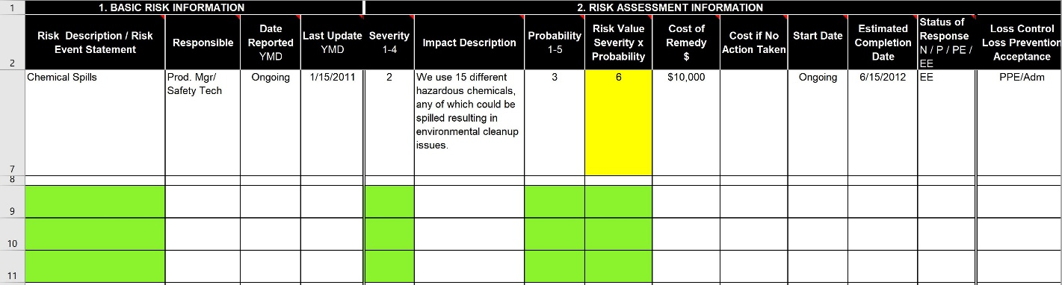

**Portion to Complete**

Risk Matrix

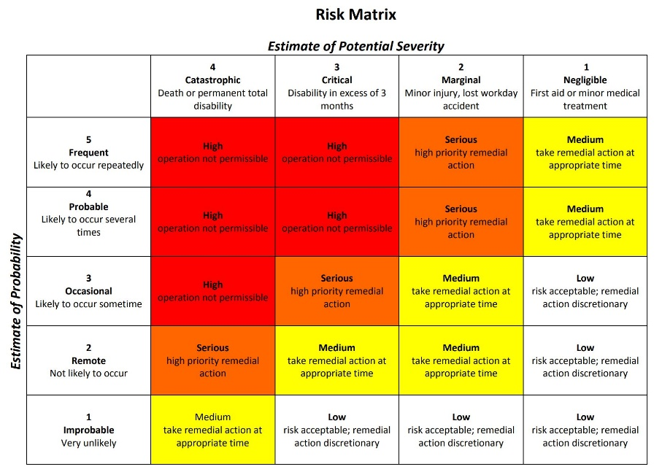

Online Form

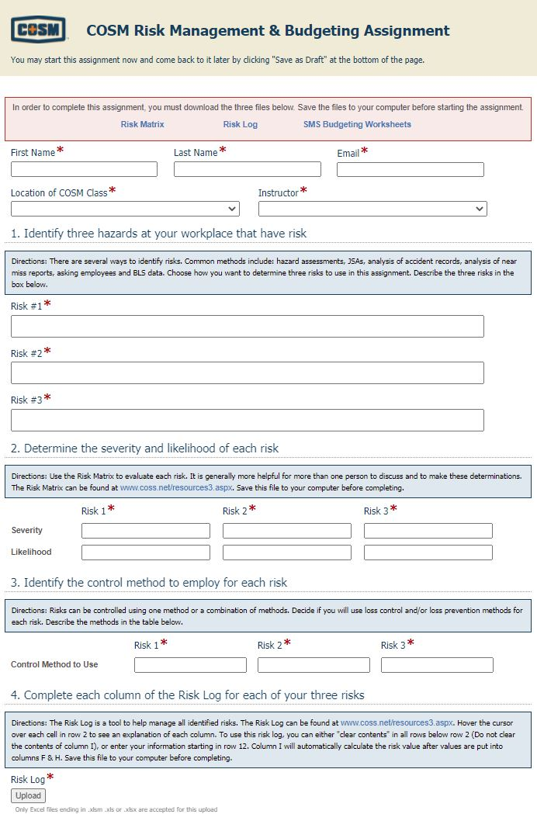

Accepted/

Rejected Feedback will be sent to the email address provided here.

Complete

ALL Fields

Must Upload Completed Risk Log

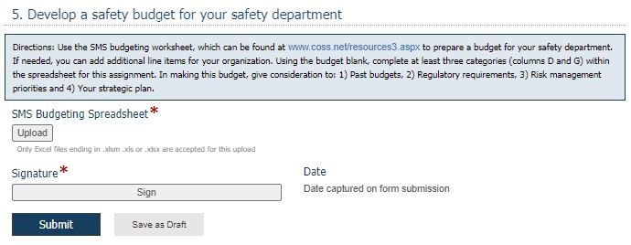

Must Upload Completed Budgeting Worksheet

Budgeting Worksheet Example

Below is a portion of the budgeting worksheet. To review a full example budget, select the “Budget Example” sheet within the document. For further instructions, see the “Instructions” sheet within the document.

