concepts of human motivation
It's hard to overstate the importance of workers' job satisfaction. Happy workers lead to happy customers, and happy customers lead to successful businesses. This discussion will provide an overview of the concepts based on research and psychological theories that try to explain what it takes to get employees to perform at a high level.

MOTIVATION AND MASLOW'S
HIERARCHY OF NEEDS
According to Maslow, motivation arises from need. That is, people are motivated to satisfy unmet needs.
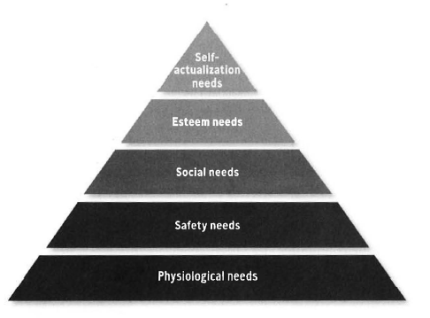
Physiological needs: Basic survival needs, such as the need for food, water, and shelter.
Safety needs: The need to feel secure at work and at home.
Social needs: The need to feel loved, accepted, and part of the group.
Esteem needs: The need for recognition and acknowledgment from others as well as self-respect and a sense of status or importance.
Self-actualization needs: The need to develop to one's fullest potential.

NOTE: A satisfied need is no longer a motivator.
To compete successfully, organizations must create a work environment that includes goals such as social contribution, honesty, reliability, service, quality, dependability, and unity.
One technique: ask small groups of housekeepers what would happen if they weren't there every day. Then ask them to come up with some other name for what the job is. In the end, these employees have a sense of how the customer's experience wouldn't be the same without them. This gives meaning to their work that helps satisfy higher-level needs.

HERZBERG'S MOTIVATING FACTORS
This involves exploring what managers can do with the job itself to motivate employees. Psychologist Frederick Herzberg asked workers to rank various job-related factors in order of importance relative to motivation.
What creates enthusiasm for workers and makes them work to full potential? The most important factors were:

- Sense of achievement
- Earned recognition
- Interest in the work itself
- Opportunity for growth
- Opportunity for advancement
- Importance of responsibility
- Peer and group relationships
- Pay
- Supervisor's fairness
- Company policies and rules
- Status
- Job security
- Supervisor's friendliness
- Working conditions

Factors receiving the most votes all clustered around job content.
Workers did not consider factors related to job environment to be motivator. One of those factors was pay. Motivators made employees productive and gave them satisfaction. Hygiene factors related to the job environment could cause dissatisfaction if missing but would not necessarily motivate employees if increased.
Herzberg's motivating factors research led to this conclusion:
The best way to motivate employees is to make their job interesting, help them achieve their objectives, and recognize their achievement through advancement and added responsibility.

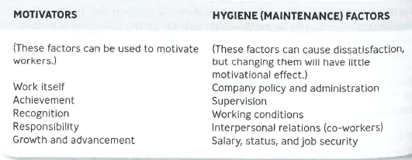

MASLOW AND HERZBERG

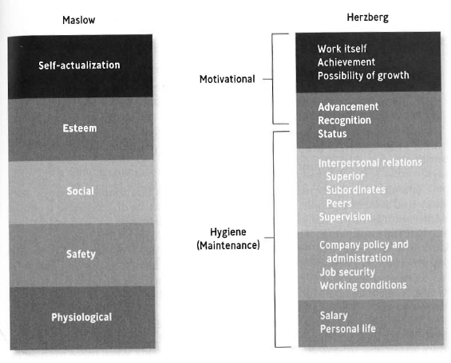

MCGREGOR'S THEORY X AND THEORY Y
A key technique here is empowerment—giving employees authority to make decisions and tools to implement the decisions they make. For empowerment to be a real motivator~ management should follow these three steps:
- Find out what people think the problems in the organization are.
- Let them design the solutions.
- Get out of the way and let them put those solutions into action.
Often employees complain that although they're asked to engage in company decision-making, their managers fail to actually empower them to make decisions.

OUCHI'S THEORY Z
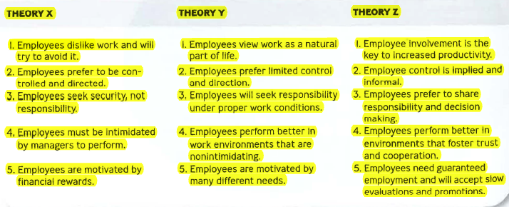
Theory Z includes long-term employment, collective decision-making, individual responsibility for the outcomes of decisions, slow evaluation and promotion, moderately specialized career paths, and holistic concern for employees (including family). Theory Z views the organization as a family that fosters cooperation and organizational values.

EXPECTANCY THEORY
The amount of effort employees exert on a specific task depends on their expectations of the outcome. Vroom contends that employees ask three questions before committing their maximum effort to a task: (1) Can I accomplish the task? (2) If I do accomplish it, what’s my reward? (3) Is the reward worth the effort?
Researcher David Adler and Edward Lawler modified Vroom's theory and suggested that managers follow five steps to improve employee performance:
- Determine what rewards employees’ value.
- Determine each employee's desired performance standard.
- Ensure that performance standards are attainable.
- Guarantee rewards tied to performance.
- Be certain that employees consider the rewards adequate.

REINFORCEMENT THEORY
This theory states that positive and negative reinforcers motivate employees to behave in certain ways. Motivation is the result of the carrot-and-stick approach: individuals act to receive rewards and avoid punishment. This is the basis for most safety incentive and rewards programs.
Further applications of the theory are in the form of positive reinforcements that are rewards such a praise, recognition, and a pay raise. Negative reinforcement includes reprimand, reduced pay, and layoff or firing.
In some cases, a manager might also try to stop undesirable behavior by not responding to it. This response is called extinction because managers hope the unwanted behavior will become extinct.

EQUITY THEORY
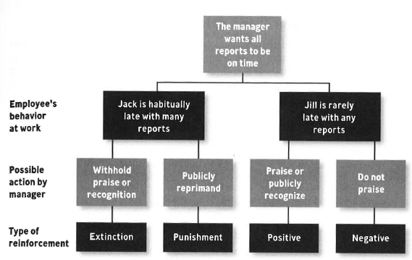
According to Equity Theory, in the workplace, perceived inequity may lead to lower productivity, reduced quality, increased absenteeism, and voluntary resignation. Remember that equity judgments are based on perception and are therefore subject to error. When workers overestimate their own contributions-as happens often- they feel any rewards given out for performance are inequitable. The best remedy is generally clear and frequent communication.

Motivation through Job Enrichment
Managers have extended both Maslow's and Herzberg's theories through job enrichment, a strategy that motivates workers through the job itself. Work is assigned so that individuals can compete an identifiable task from beginning to end and are held responsible for successful achievement.
Five characteristics of work are important in motivation and performance:
- Skill variety. The extent to which a job demands different skills.
- Task identity. The degree to which the job requires doing a task with a visible outcome from beginning to end.
- Task significance. The degree to which the job has a substantial impact on the lives or work of others in the company.
- Autonomy. The degree of freedom, independence, and discretion in scheduling work and determining procedures.
- Feedback. The amount of direct and clear information given about job performance.

Motivating through Open Communication
Communication and information must flow freely throughout the organization when employees are empowered to make decisions.
- Create an organizational culture that rewards listening
- Train supervisors and I1'wnagers to listen
- Use effective questioning techniques
- Remove barriers to open communication
- Avoid vague and ambiguous communication
- Make it easy to communicate
- Ask employees what is important to them

Applying Open Communication in Self-Managed Teams
At Ford Motor Company, for example, a group known as Team Mustang set the guidelines for how production team should be formed. The 400-member team was also given the freedom to make decisions without waiting for approval from headquarters. To implement such teams, managers at most companies must reinvent work. This means respecting workers, providing interesting work, developing workers' skills, allowing autonomy, decentralizing authority, and rewarding good work.

Recognizing a Job Well Done
Letting people know you appreciate their work is usually more powerful than giving a raise or bonus alone. Noticing positive actions aloud, making employees feel their efforts are worthwhile and valued enough to be noticed.
- A sundae surprise of gourmet ice cream and toppings.
- Netflix and XM Satellite Radio memberships.
- Three paid days off to work for a nonprofit of their choice.
- A free snack cabinet, free coffee, and free unlimited city commuting.
- Spirit of Fred Award:
- Friendly, Resourceful, Enthusiastic, and Dependable.
- Flowers in appreciation or a job w it done…. And that employee passes the bouquet to someone else who helped.
- Golden Banana Award for a job well done.
- Prime parking spots,
- More vacation days, or
- More flexible schedules
- A small equity stake or stock options often have a good chance of developing loyal employee

Motivating Employees across Generations
Millennials rely on experiences they shared in their formative years-usually the first 10 years of life. The beliefs we all accept as children affect how we view risk, challenge authority, technology, relationships, and economics. When you're in a management position, these experiences can even affect whom you hire, fire, or promote.
Young workers demand performance reviews and other forms of feedback more than the traditional one or two time a year. They are impatient, skeptical, blunt and expressive, image-driven, and inexperienced, adaptable, tech-savvy, able to grasp new concepts, practiced at multitasking, efficient, and tolerant. Perhaps the most surprising attribute the share is a sense of commitment. They are "job surfing" and aren't opposed to living with their parents while they test out jobs. A recent study found Millennials place a higher value on work-life balance, expect their employers to adapt to them (not the other way around), and are more likely to rank fun and stimu1ation in their top five ideal job requirements.
One thing in business is likely to remain constant: much motivation will come from the job itself rather than from external punishments or rewards. Managers need to give workers what they require to do a good job: the right tool, the right information, and the right amount of cooperation.
Motivation doesn't have to be difficult. It begins with acknowledging a job well done-and especially doing so in front of others.

CONCLUSION
The word engagement is used to describe employees' level of motivation, passion, and commitment. Engaged employees work with passion and feel a connection to their company. Disengaged workers have essentially checked out; they plod through their day putting in time, but not energy. Not only do they act out their unhappiness at work, but disengaged employees undermine the efforts of engaged co-workers. A recent Gallup study showed that 29 percent of U.S. employees are actively engaged in their jobs, 54 percent are not engaged, and 17 percent are actively disengaged. Another Gallup survey estimated that the lower productivity of actively disengaged workers costs the U.S. economy about $300 billion a year.
Motivating the right people to join the organization and stay with it is a key function of managers. Top-performing mangers are usually surrounded by top-performing employees. It is no coincidence that geese fly faster in formation than alone. Although the desire to perform well ultimately comes from within, good managers stimulate people and bring out their natural drive to do a good job. People are willing to work, and work hard, if they feel their work makes a difference and is appreciated.
People are motivated by a variety of things, such as recognition, accomplishment, and status. An intrinsic reward is the personal satisfaction you feel when you perform well and complete goals. The belief that your work makes a significant contribution to the organization or to society is a form of intrinsic reward. An extrinsic reward is given to you by someone else as recognition for good work. Pay increases, praise, and promotion are forms of extrinsic rewards.
The point of all this is to say that both theoretical thinking and research indicate that employees need engagement and recognition in or to go over and above what is expected. How can you make it happen in your organization?

Source: Nickels, William G., McHugh, James M., McHugh, Susan, M., Understanding
Business, ninth edition, pages 254-280, Boston, McGraw-Hill Irwin, 2010.

