REASON’S Just Culture Decision Tree
The process of determining if disciplinary action is needed and getting to the root cause of the problem which may occur.
Source: Reason (1997) A decision tree for determining the culpability of unsafe acts. p209)
Were the actions intended?
Were the consequences intended?
Unauthorized substance?
Medical condition?
Knowingly violated safe operating procedures?
Pass
Substitution
test?
Were procedures available,
workable, intelligible
and correct?
Deficiencies in training & selection or inexperience?
History of unsafe acts?
Sabotage, malevolent damage, suicide, etc.
Substance abuse w/o mitigation
Substance abuse with mitigation
Possible negligent error
System-induced error
Blameless error but corrective training or counseling indicated
Blameless error
Possible reckless violation
System-induced violation
Diminishing Culpability
NO
NO
NO
NO
NO
NO
NO
NO
YES
YES
YES
YES
YES
YES
YES
YES
YES

hUDSON’S rEFINED jUST cULTURE mODEL
Source: Hudson’s refined Just Culture Model (From the Shell “Hearts and Minds” Project, 2004)
Coach managers & supervisors to recognize & deal with such individuals
Did they follow all procedures & best practices?
Mgmt. needs to examine qualify of procedure system
Everyone use MRB to see if rule is necessary or ensure compliance
Description | Oh, dear! Did we do that?!  Did they think they were following procedures & best practices?  Did they follow all procedures & best practices?  Everyone does it this way around here  Screw You! I meant to do it my way  I thought it was better for me personally to cut a corner  We can’t follow procedure & get the job done  I thought it was better for the company to do it that way
Violation Type | Normal  Compliance | Unintentional  Violation  Awareness/  Understanding | Routine  Violation | Situational  Violation | Optimizing  Violation | Personal  Optimizing  Violation | Reckless  Personal Optimization | Exceptional Violation
Management | Feel comfortable, but be aware this may be unusual  How did we hire such a person?  Set standards examine hiring & retention policies  Set standards. Examine procedures this may be a real improvement  Get very active. How were poor procedures signed off?  Why didn’t people realize this was a problem?  Did we not expect such situations to arise? HSE-MS problem?  Take active steps to identify sort of violation (MRB)
Supervision | How did we let him stay here? Didn’t we know in advance?  Set standards recognize that such people are in workforce  Why is this not being recognized? Use MRB allow variances  Did we train people in how to react in unusual circumstance?  Investigate. Must listen to workforce  Investigate & apply MRB  Praise the worker  Investigate and apply MRB
Workforce  Feel  satisfied | Leave  company  Decide whether you wish to work here  Report possibility raise before work acquire competence  Did I check with supervisor and colleagues?  Must report all such impossible situations  Get involved in finding out if procedure is necessary  Report if they discover they have violated a procedure
Discipline | Did they follow all procedures & best practices?  Warning letter to worker  Summary dismissal  None  No blame for worker  Active coaching of all levels for condoning routine violation  Blame everyone for not playing their part  Blame everyone for not playing their part
Coaching | Coach managers & supervisors on setting standards  Coach people to tell workers & listen to mgrs. and supervisors  Coach people to tell workers & listen to mgrs. and supervisors  Praise the worker & use as example for others

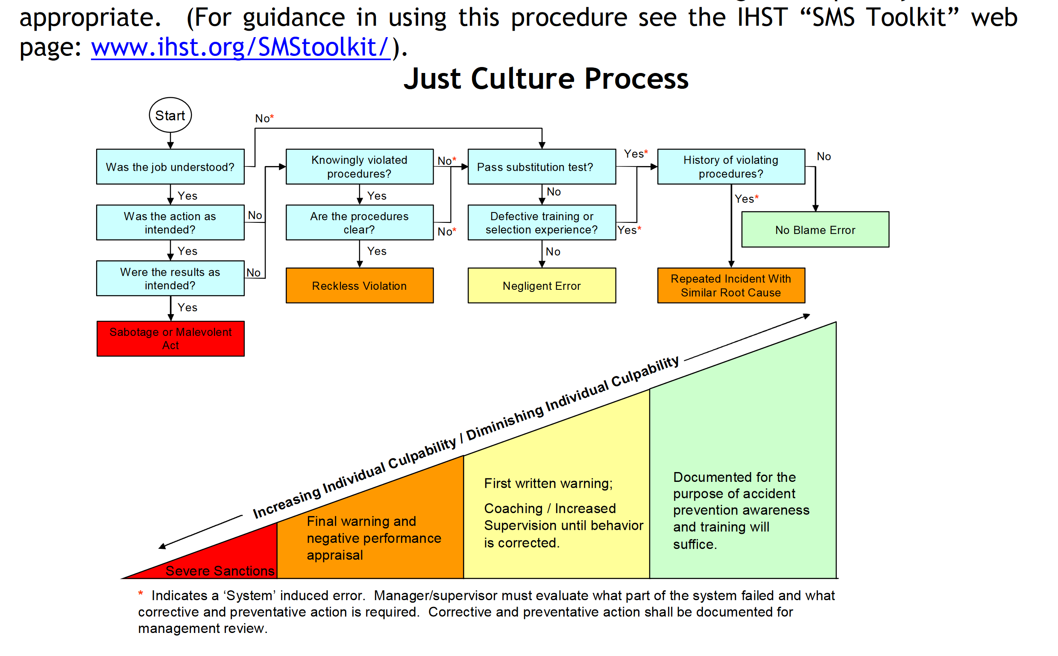
IHST jUST cULTURE pROCESS
Source: Safety Management System Toolkit. September 2007. Joint Helicopter Safety Implementation Team of the International Helicopter Safety Team, Montreal, Canada, (see page 29). http://www.ihst.org/Portals/54/SMS-Toolkit.pdf

